Gynii Abracosa Gilliam, President of Jobs Plus EDC

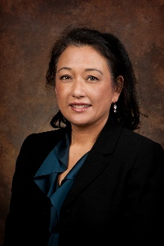
Gynii joined the Coeur d’Alene Area EDC/Jobs Plus in March of 2015. She is charged with helping create vital communities in the region by diversifying the economy and helping business create jobs. Since joining Jobs Plus, she’s been instrumental in expanding the focus of the organization and in building a strong community economic development team that she credits with helping over a dozen expanding and relocating businesses bring $126M of new capital to Kootenai County, along with over 1100 new jobs in 2016 and 2016.

She has over 25 years of experience in the field, in both the private and public sectors, from rural communities to urban centers. She served as the Chief Economic Development Officer for the State of Idaho, where her team helped bring over $700 million in capital investment and 3500 new direct jobs to the state over an 18-month period. Prior to joining CdAEDC/Jobs Plus, Gynii had a private consulting firm focused on providing workshops to help “Elected Officials and Stakeholders become Champions for Economic Development.” She has also taught a graduate course in Community and Economic Development, while serving as an adjunct professor for Boise State University. Additional previous experience also includes successful projects in the Pocatello and Challis/Salmon areas in eastern and central Idaho, along with projects in Los Angeles and Detroit.

Ms. Gilliam holds a Master’s Degree in Urban and Regional Planning from the University of Michigan, Ann Arbor, a Bachelor’s Degree in Political Science from the University of California, Los Angeles and studied abroad at the University of Copenhagen in Denmark. She was a California State Scholar and the recipient of the Rackham Graduate School Fellowship.

Gynii is involved in local, regional and national boards, including the International Economic Development Council, Inland Northwest Economic Development Partnership and the Idaho State Economic Development Association. She has presented at the National Council of State Governments, the Northwest Food Processors Association, the Pacific Northwest Economic Development Council, and at many other national events. Gynii has two grown boys: Jono an Architect in Los Angeles, California; and Michael, an ER Nurse in Boise, Idaho.

