It’s a Mad Mad World
Develop your talent pipeline and overcome hurdles!
November 8-10th
Riverside Hotel Boise Idaho
Tuesday November 8th
2:00 – 4:00 Tour Downtown Boise’s Convention Center Expansion and JUMP
JUMP is located in the heart of downtown Boise, between Front and Myrtle Streets and 11th and 9th Streets.
Jack's Urban Meeting Place, 1000 West Myrtle Street, Boise, ID 83702, 208-639-6610
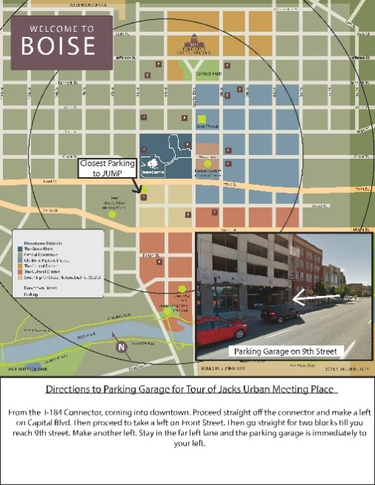
JUMP – Jack’s Urban Meeting Place - Two years ago we toured the under construction JUMP project and could only imagine what it would become. Today it is a community amenity like nothing else! The world headquarters for Simplot are now under construction to complete this massive development project. Come tour this site and see this amazing community asset.
Boise Centre Expansion - We will also tour the new expansion of the downtown convention center space which includes new ballroom and meeting space across the Grove Plaza from existing and which is also located on top of the Main Street Station, the new underground transit station and alongside the new office building which includes BSU’s computer science department and the business operations of Clearwater Analytics. Come see this new building in downtown Boise that is opening this fall.
4:30 – 5:30 Board Meeting
Board Meeting Riverside Doubletree Board Room—2900 Chinden Boulevard
6:00 Board Dinner – Joe’s Crab Shack—2288 N Garden St
Wednesday November 9th
8:00 – 8:30 Breakfast Networking – HOT topic: what happened last night!
8:30 – 9:00 Welcome and Introductions
9:00 – 10:00 How is State Government supporting economic development in Idaho?
Megan Ronk, Director Idaho Department of Commerce
What is on the horizon for the Department of Commerce? How can we further economic development efforts at the state level?
Lt. Governor Brad Little, Economic Development in Idaho.
What can Idaho do to be the most competitive state in growing business and industry? What is the outlook for the future and the upcoming legislative session? Are there any opportunities for economic development in the Governor’s 2018 budget?
10:00 – 11:15 Align, Engage and Advance: Successful Case Studies Using Idaho’s Workforce Development Training Fund
Idaho businesses and local economic development groups have tapped more than $88 million in Workforce Development Training Funds to create talent pipelines and solve local workforce challenges. How are these groups engaging industry and education in developing meaningful and effective training programs? Are these projects making a difference in Idaho? During this session, panel participants will talk about how their economic development organizations are using new industry sector and micro grants to help businesses equip their employees with the right skills.
Moderator:
- Carmela Ramirez, Idaho Workforce Development Training Fund Grants Program Manager - Idaho Department of Labor
Panelists:
- Marie Price, Director, North Idaho College Workforce Center: Building a Workforce for Idaho’s Aerospace and Forest Product Industries
- Courtney Lewis, Mountain Home Economic Development: Solid Works and CompTIA Classes
- Tammy Stringham, Lemhi County Economic Development Association: EITC & the Steele Memorial Hospital Certified Nursing Assistant Program
11:15 – 12:00 Sponsor and Partner Updates
12:00 – 1:15 Networking Lunch/ 12:30 Committee Meetings
1:15 – 2:15 Helping to create pipelines and find available talent in your community.
Charity Nelson, Boise Valley Economic Partnership, and panel
Identify strategies to help economic development professionals connect businesses in their communities to talent pipelines by developing robust internship programs and connecting companies with state and local educational institutions.
2:30 – 3:30 Building Talent Pipelines from the Ground Up
Supporting local career planning efforts is just one way Idaho's economic development community can help build talent pipelines from the ground up. Introducing students to companies with jobs in demand and connecting students with potential career paths are just a few examples. Walk away from this session with ideas on how your local economic development association can support career planning in the schools and help build Idaho’s workforce from the ground up. Local economic development groups are becoming more involved in developing talent pipelines and making sure our next generation is trained for the jobs of the future by introducing students to companies that have these jobs. Walk away from this session with ideas on how your local economic development association can support career planning in the schools and help build the state’s workforce of the future from the ground up.
Moderator: Georgia Smith, Communications & Research, Idaho Department of Labor
Panelists:
- Marilyn Whitney, Education Policy Advisor, Office of Governor C.L. “Butch” Otter
- Sara Scudder, Administrator, Idaho Career Information System
- Christine Frei, Clearwater Economic Development Association
- Dr. Harold Nevill, Director, COSSA
3:30 – 4:30 Building Relationships With Elected Officials
Senator Kelly Anthon, Senator for the State of Idaho
Learn from sitting and retired officials on how to develop and enhance your relationships with elected officials. In this session, you will learn about best practices of communicating and effectively interacting with elected officials. Learn some tips and ideas about setting appointments, planning the meeting, accomplishing your goals, objectives and following up after the meeting. Discussion will also focus on the perspective of elected officials about what they would like to accomplish when meeting with subject matter experts.
4:30 – 5:30 No-Host Social Get-Together at Telaya Winery
Telaya Winery opened a new tasting room along the Boise River in 2015 which is next to Riverside Hotel. Grab some IEDA members and walk over to enjoy this beautiful facility along the Boise River. You can review the sessions of the first day of the conference while enjoying some Idaho Wines, or just sit on patio and get reconnected with economic development professionals from around the state!
Thursday November 10th
8:00 – 8:30 Breakfast
8:15 – 8:45 Committee Reports to the Membership
8:45 – 9:15 Annual Meeting for Membership & Election of Officers
9:30 – 10:30 I’ll Push You
Justin Skeesuck and Patrick Gray
Hear an incredible story of friendship, courage and determination. Justin Skeesuck and Patrick Gray are native to the Boise Valley and in 2012 Justin became the first person in a wheelchair to complete a 500 mile pilgrimage across northern Spain called the Camino de Santiago.
10:45 – 12:00 Telling your Community’s Story, Responding in Challenging Times
Ysabel Bilbao
As companies become increasingly conscious of public policy and actions regarding civil rights it is important for economic development professionals to participate in crafting the message of how communities respond to these challenges. Gain tips on how we can support our leadership in crafting our community response and messaging.
12:00 – 1:00 Networking Lunch and Presentation of the Bob Potter Economic Developer of the Year Award
1:00 – 2:00 The ApprenticeshipIdaho Initiative
John Russ, IDOL and Wendi Secrist, ICTE
The Idaho Department of Labor recently received a $200,000 Apprenticeship Accelerator grant from the US Department of Labor and is in the process of applying for $1.9m in additional funds to support the development of apprenticeships in non-traditional fields (i.e. healthcare, information technology and advanced manufacturing). This initiative will link Workforce Training, Career & Technical Education and Labor into a statewide talent pipeline development system. Learn about the initiative and how you can engage to help local businesses develop apprenticeship programs that lead in high wage, in-demand careers.

2:00 – 2:15 Closing and wrap up

